**How to login to instances using the keypair**

Please download puttygen.

In the puttygen select **LOAD** button.

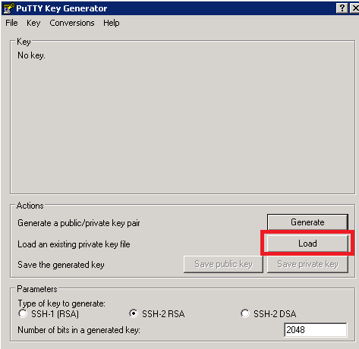

Select the .pem file which was located and given **OPEN.**

Enter the key passphrase and the give **SAVE PRIVATE KEY** and select ok.

Passpharse is optional .

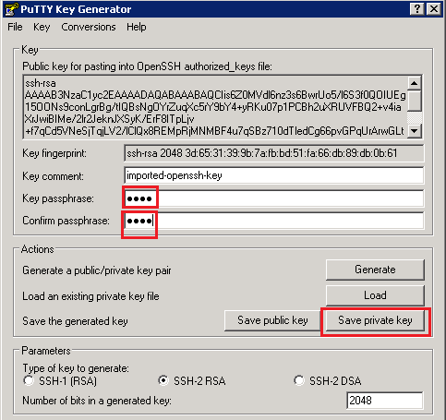

Enter the privatekey file name with .ppk and save it.

Click OK.

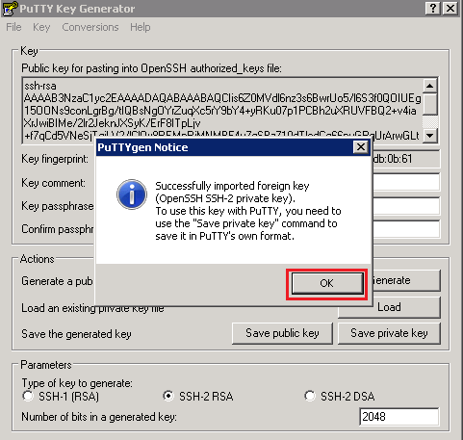

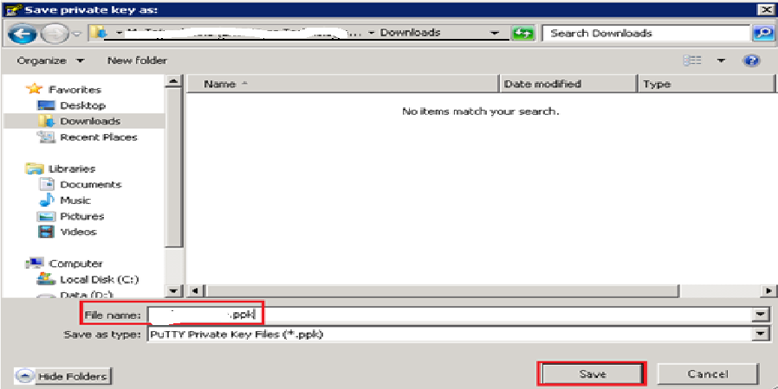

In the putty, Catergory select connection🡪 ssh 🡪 Auth

Select the private key file by browse option

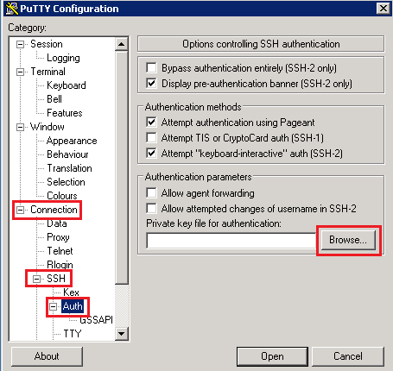

Enter the instance ip (Public IP) with port number 22 and give **OPEN**

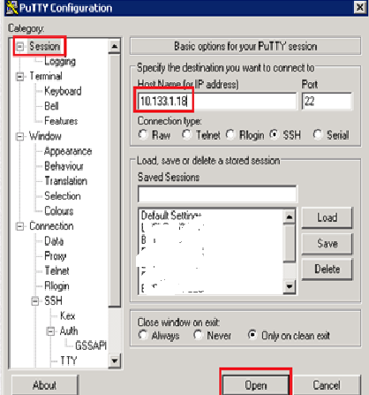

Enter the login as root and password and login to the instance.

**To login from a LINUX machine using KeyPair File**

Ssh –i <keypair>.pem root@<Public IP>